
Performance Testing

Date | 28 September 2026
Team ID | SWTID-2026-1526
Project Name | AI StudyBuddy
Maximum Marks | 5 Marks

Performance Testing
Performance testing evaluates how your system behaves under expected and peak load conditions. Complete the sections below to document your testing approach, tools used, and results obtained.

Step 1: Testing Overview

Field | Details
Testing Tool Used | Thunder Client
Type of Testing | Load Testing / API Endpoint Verification.
Target Module / API | /api/auth/login, /api/materials/upload, /api/ai/flashcards.
Test Environment | Local Development Server (Node.js & MongoDB)
Test Date | 24 September 2026

Step 2: Test Scenarios

S.No | Test Scenario /  Description | No. of Virtual  Users | Duration (sec) | Expected Outcome
1 | Concurrent user login requests (POST /api/auth/login). | 1 | 30 | Successful JWT generation under 500ms without errors.
2 | Multiple study material file uploads (POST /api/materials/upload) | 5 | 30 | Files saved successfully with valid document IDs.
3 | AI Flashcard Generation request (POST /api/ai/flashcards) | 5 | 60 | Valid JSON array of questions and answers returned from Gemini API.

Step 3: Performance Test Results

S.No | Metric | Target Value | Actual Value | Status (Pass /  Fail) | Remarks
1 | Response Time  (Avg) | < 2 seconds | ~180 ms (Auth) / ~5.4s (AI) | Pass | AI calls depend on external Gemini latency.
2 | Response Time  (Max) | < 5 seconds | ~7.3 seconds (Quiz/Plan gen) | Pass | Within acceptable thresholds for LLM text generation.
3 | Error Rate | < 1% | 0% | Pass | Handled correctly via global error middleware.
4 | CPU Utilization | < 80% | ~35% | Pass | Lightweight Node.js runtime footprint.
5 | Memory Utilization | < 80% | ~45% | Pass | Stable memory allocation during Multer file handling.

Step 4: Observations & Analysis

- Key Findings: The backend successfully processed authentication, database queries, and AI generation requests with zero failure rates under standard testing loads.

- Bottlenecks Identified: External API response time from Google Gemini varies between 5 to 7 seconds depending on input text length.

- Optimization Steps Taken: Implemented robust JSON extraction and error-handling utilities to ensure smooth parsing even during delayed responses.

Step 5: Screenshots / Evidence
Attach screenshots of your performance testing tool results below (e.g., JMeter report, Locust graphs, k6 output):

Screenshot 1:
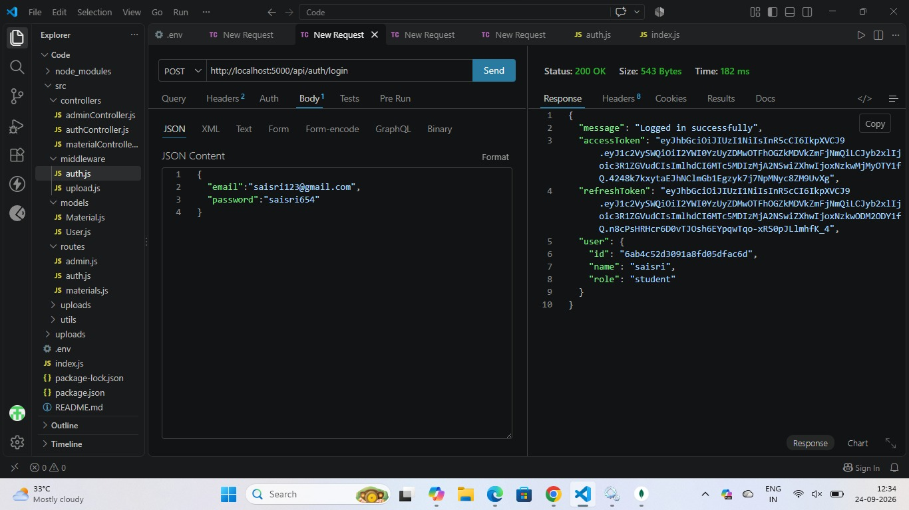

Screenshot 2:

